SIMATS ENGINEERING
CO5-ASSESSMENT TOOL 3

COURSE NAME: DIGITAL CIRCUITS COURSE CODE: ECA02

COURSE OUTCOME COVERED
CO:5 Analyze the operation and characteristics of NMOS and PMOS transistors, CMOS inverters, and MOS device parameters used in digital circuit design (BTL 3 & 4)

Assessment Tool number : AT3
Assessment Tool Weightage : 40%
Assessment Tool Name : HDL Code Error Debugging
Duration of this assessment : 90 Minutes
Marks : 20
Type of Assessment conduction : Inside Class

Description:

- Each student will be assigned one HDL Code Error Debugging problem 20 marks inside class. Analyze and debug one faulty analog circuit.
- Simulate the corrected circuit using VIVADO and verify results.
- Document the debugging process, observations, and conclusions.
- Upload VIVADO files, simulation results, and report to GitHub.
- Evaluation is based on fault identification, debugging approach, simulation accuracy, documentation, and GitHub submission.

Item | Student Entry
1. Given Code | module dff(  input clk, D,  output reg Q  );  always @(clk)  Q <= D;  endmodule
2. Expected code output | Q = D
3. Observed Fault / Symptom | always @(clk)
4. Error Identified | Incorrect:  always @(clk)  Correct  always @(posedge clk)
5. Correction Made | Correction Made  Replace:  always @(clk)  with:  always @(posedge clk)
6. Corrected HDL code | module dff(  input clk, D, output reg Q  );  always @(posedge clk)  Q <= D;  endmodule
7. Verification / Simulation Output | 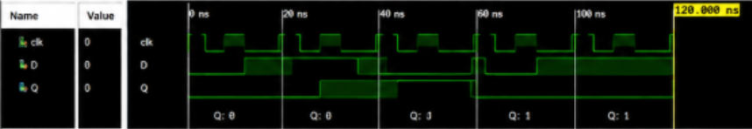
8. Final Result & Technical Justification | module dff(  input clk, D,  output reg Q  );  always @(posedge clk)  Q <= D;  endmodule

